Sixth lecture
PHOSPHORUS

In contrast to nitrogen , which constitutes 79% of earth
Atmosphere , P is present as mineral deposits
15-20% of applied -P fertilizer becomes available to crop
And still smaller fraction to succeeding crops
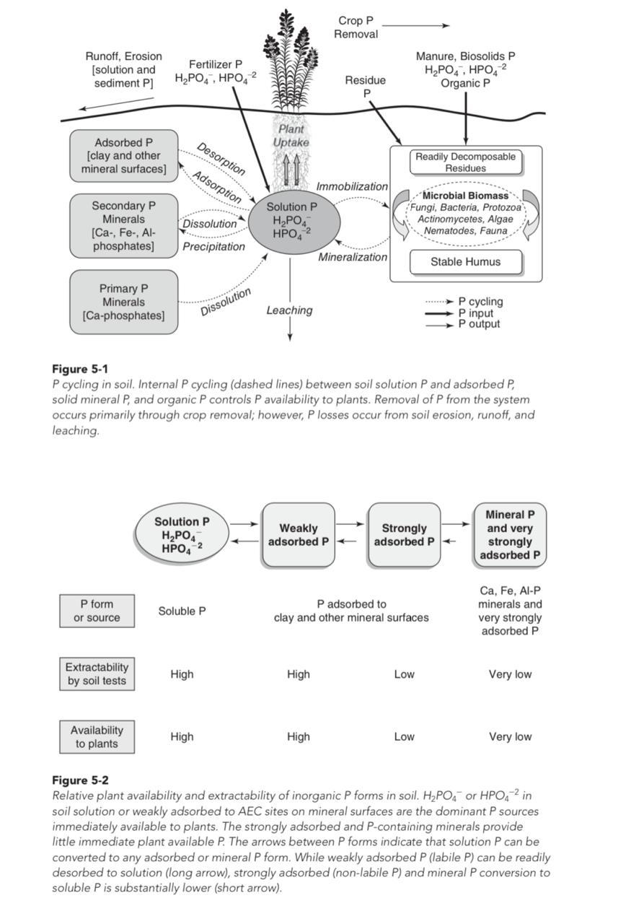
FORMS AND FUNCTIONS OF P IN PLANTS
Forms
P concentration in plants ranges between 0.1 and 0.5%, considerably lower than Nand K. Plants absorb either H2PO4⁻ or HPO4⁻² (orthophosphate) depending on soil
pH
Although it has been suggested that plants also absorb soluble, low-molecular weight
organic P compounds (i.e., nucleic acid and phytin), these P compounds are likelyconverted to H2PO4⁻ in the rhizosphere.
Functions
The most essential function of P in plants is in energy storage and transfer.
Adenosine diphosphate (ADP) and adenosine triphosphate (ATP) act as “en-ergy currency” within plants When the terminal H2PO4- molecule from either ADP or ATP is split off, a large amount of chemical energy (12,000cal/mole) is liberated. Energy obtained from photosynthesis and metabolism of carbohydrates is stored in phosphate compounds for subsequent use in growth and reproductive processes. Phosphorylation is the transfer of energy-rich H2PO4⁻ molecules from ATP to energy-requiring substances in the plant. In this
reaction ATP is converted to ADP. ADP and ATP are formed and regenerated in carbohydrates is stored in phosphate compounds for subsequent use in growth
and reproductive processes. Phosphorylation is the transfer of energy-rich H2PO4- molec
the presence of sufficient P. Almost every metabolic reaction of any significance involves H2PO4- derivatives As a result, P deficiency is associated with restricted growth and development.
P is an essential element in deoxyribonucleic acid (DNA) and ribonucleicacid (RNA) that contain the genetic code of the plant to produce proteins and other compounds essential for plant structure, seed yield, and genetic transfer.
Phospholipids, phosphoproteins, coenzymes, and nucleotides are important structural components of membrane chemistry and related functions.
Thus, P
is essential for vigorous growth and development of reproductive parts (fruits,seeds, etc.).
Adequate P
is associated with increased root growth. When soluble H2PO4- is applied in a band, plant roots proliferate extensively in P-treated soil.
Similar observations are made with both NO3- and NH4+ applied in a band near roots The increased root proliferation should encourage extensive exploitation of the treatedsoil areas for nutrients and water. Adequate P is essential for fruit and seed development. P also enhances crop maturity and reduces the time required for seed and fruitripening
Adequate P
increases straw strength in cereals and increases N2 -fixation capacityof legumes. The quality of certain fruit, forage, vegetable, and grain crops is improved
and disease resistance enhanced under adequate P availability. The effect of P on raising the tolerance of small grains to root-rot diseases is particularly noteworthy. Also, the riskof winter damage to small grains can be decreased with sufficient P, particularly on low P soils and with unfavorable growing conditions.
P is mobile in plants, and is translocated from older to newly developing tissues. Consequently, early growth stage responses to P are common. In the reproductive stage, P is translocated to fruit and seeds. Thus, P deficiencies late in the growing
season affect both seed development and crop maturity.
Total Soil PHOSPHORUS
PHOSPHORUS content of soils is generally less than of total N or K , Total PHOSPHORUS content in surface
Soil and subsoil may vary from a few mg kg ⁻¹ to over 1 gkg⁻¹ . Also in contrast to soil N , which is concentrated in surface soil , P content in subsoil may be less than ,
Equal to , or greater than that in surface soil as fig. 9.1

Data show that P is present in soils both in organic and
Inorganic forms . Both organic and inorganic P
Continuously undergro transformation as shown in fig. 9.2
Solution P
The amount of H2PO4⁻ and HPO4-² present in solution depends on soil pH At pH 7.2, H2PO4⁻ ≈ HPO4⁻²
. Below this pH, H2PO4⁻ more than HPO4⁻²,
whereas HPO4-2 more than H2PO4- above pH 7.2. Plant uptake of HPO4-2 is much slower than with H2PO4-.
Soil solution P concentration varies widely among soils from 10-7 (very low) to 10-4 M (very high), or 0.003–3 ppm P (average ∼0.05 ppm).

Total P can be classified to :
- Inorganic P
In organic P in soil is mostly present as compounds
Of Ca , Fe and Al ,
Ca- phosphates dominate in natural to alkaline soils
While Fe – and Al - phosphates dominate in acidic soils
At any specific time very small amounts of phosphate
Are present in soil solution in equilibrium with the soild inorganic phase
The concentration of P in soil solution is approximately 0.05 mg⁻¹ l and seldom exceeds 0.3 mg⁻¹ l in unfertilized soils
When a water -soluble phosphate fertilizer such as super phosphate or ammonium phosphate is applied
To soil , immediately after its dissolution phosphate
Ions in solution react with Ca , Fe or Al ions present in soil solution and are precipitated as insoluble compounds or become adsorbed on surface of clay particles
These process known as fixation or reversion of phosphate
What main factors effect on fixation or reversion of phosphate ?
- PH dependent
as fig 9.3 , pH between 4 and 6 most of P in soil solution is present as H2PO4⁻¹ ion , the form in which it can be readily absorbed by root plants
because this ionic form is soluble in water
between ph 6.5 and 7.5 , P in soil solution is present
partly as H2PO4⁻¹ and partly as HPO4⁻² ion
HPO4⁻² ions can also be taken up by plants root .
Between pH 8 and 10 the PH the HPO4⁻² ion is dominant . under such conditions Na ions dominate the soil cation exchange complex and some phosphate
Is present as sodium phosphate making H2PO4⁻² ions
Available on hydrolysis
PH10 the dominant ionic form of P is PO4⁻³ , and unless present as sodium phosphate , P is not available to crop plants
At is below PH3 , which is generally not found in cultivated soils
P would be present in H3PO4 (phosphoric acid ) form
, avery reactive form .
That is why in highly acidic ultisols and oxisols , phosphate fixation or reversion is rapid and large amounts of phosphate fertilizers are required to obtain good crop growth .

Organic Soil P
Organic P represents about 50% of total soil P and typically varies between 15 and 80% ). Like OM, soil organic P decreases with depth, and the distribution
with depth also varies among soils. These data also illustrate the correlation between organic C and organic P in soils.
P content in soil OM ranges from 1 to 3%. Although soil organic P increases with increasing organic C and/or N, the C:Pand N:P ratios are more variable among soils than C:N ratio. Soils are characterized
by C:N:P:S ratio ( ). Average C:N:P:S ratio in soil is 140:10:1.3:1.3.
Most soil organic P compounds are esters of orthophosphate 1H2PO4-2 including inositol phosphates (10–50%), phospholipids (1–5%), and nucleic acids(0.2–2.5%). Inositol phosphates represent a series of phosphate esters ranging from monophosphate up to hexaphosphat

P Mineralization and Immobilization in Soils
In general, P mineralization and immobilization are similar to N in that both processes occur simultaneously in soils and can be depicted as fol

